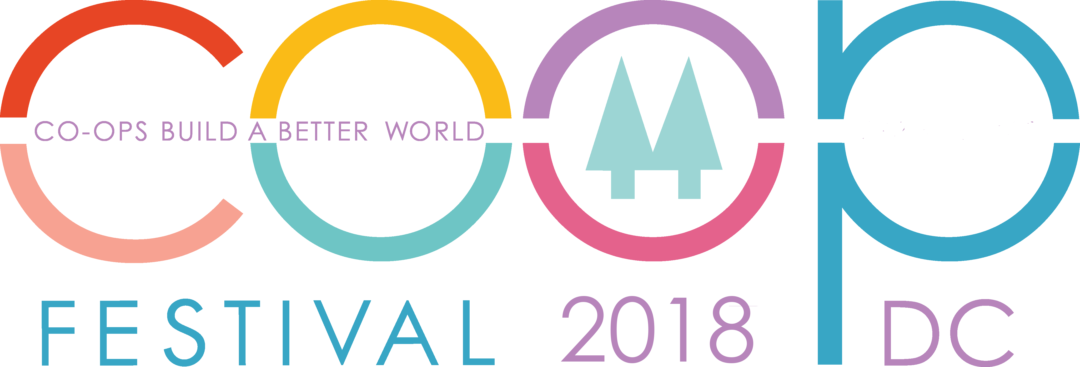

October 6-7, 2018

TENT AND EVENT ACTIVITIES DOCUMENT

YOUR LOGO HERE

Your Organization Name Here

Please Check:

- For-Profit Org
- Non-Profit Org
Describe the education mission of your tent. How will Co-op Festival attendees benefit from learning about your cooperative?

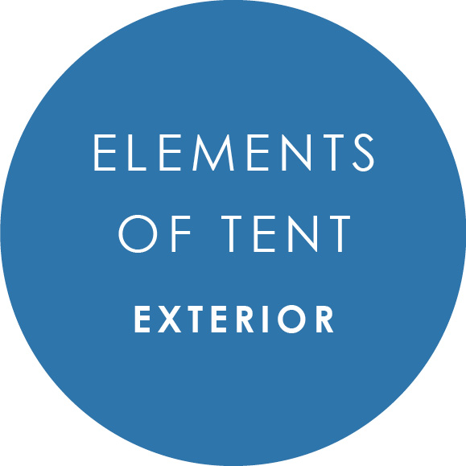
Describe any elements you plan to attach to or display on the outside of your tent, including the space around your tent.

Describe any elements you plan to attach to or display inside your tent, including video screens, collapsible displays, step & repeats, etc.

Insert example images of the elements inside or outside your tent that Co-op Festival attendees will interact or engage with (games, charging stations, etc.)

.

Insert example images of the signage (banner-ups, collapsible displays, step & repeats, etc.) you plan to display inside your tent.

Do you plan to demonstrate an activity in or just outside your tent? Describe or insert example images of the demonstration.

Your image(s) here…

If you plan to distribute any handouts at your booth (giveaways, flyers, brochures, etc.), please insert example images of them on this page.

